**EXPERIMENT NO. 3**

**TITLE :**

To create a Presentation Graphics on Nepal tourism using Power Point.

**OBJECTIVE :**

* To learn how to presentation.
* To learn how to use power point.

**THEORY :**

Presentation software is a computer application that helps users create slide shows to convey information. It can also be called a presentation program or graphics presentation application.

Microsoft PowerPoint is a presentation program that allows users to create multimedia slides. It's part of the Microsoft Office suite and is designed to be easy to use and learn.

PowerPoint allows users to create visually appealing and interactive presentations, making it a popular choice for professionals, educators, and individuals looking to deliver impact full messages effectively.

**DEMONSTRATION :**



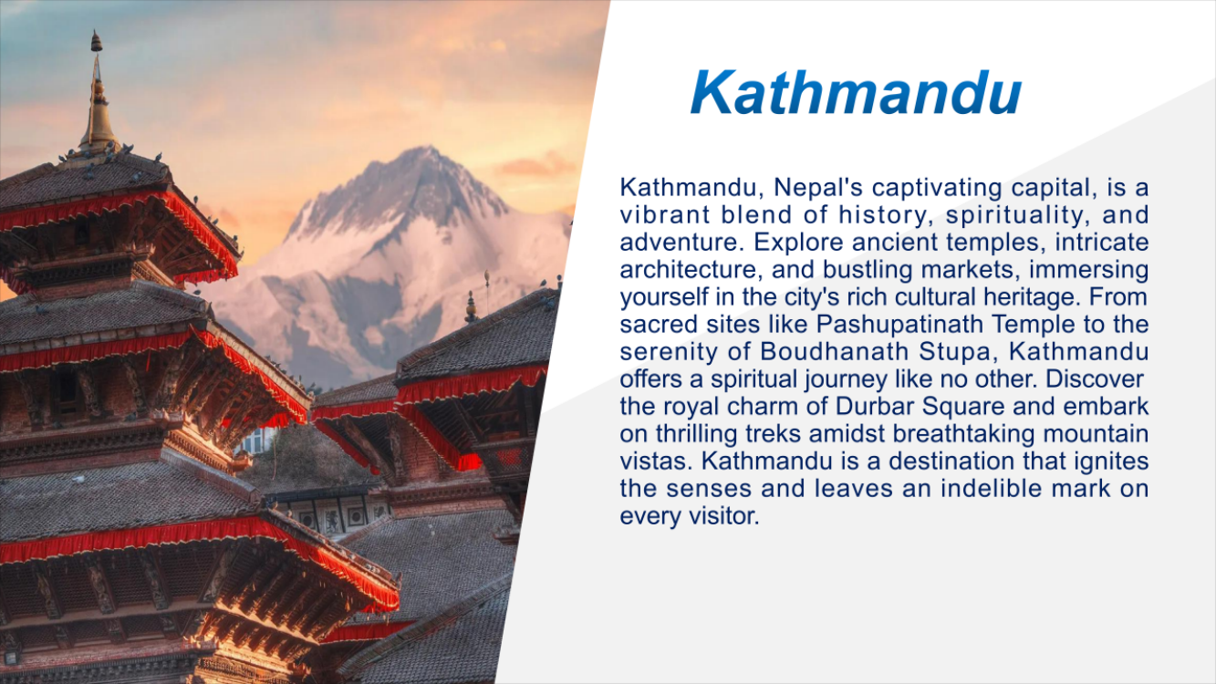

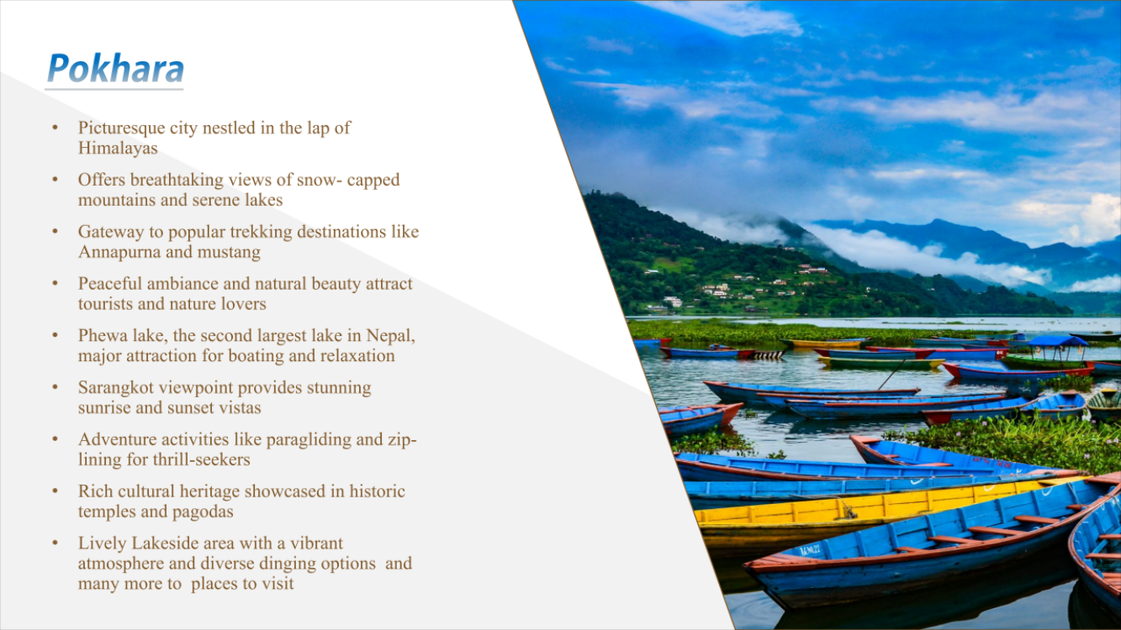

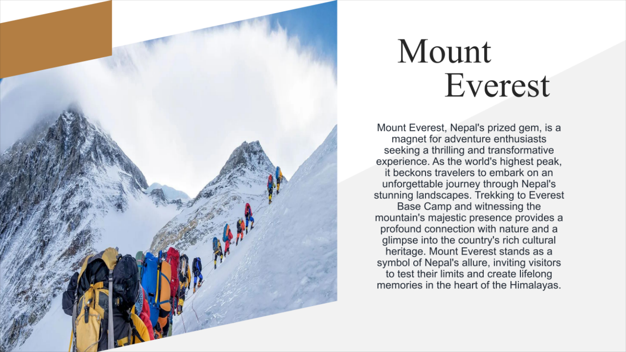

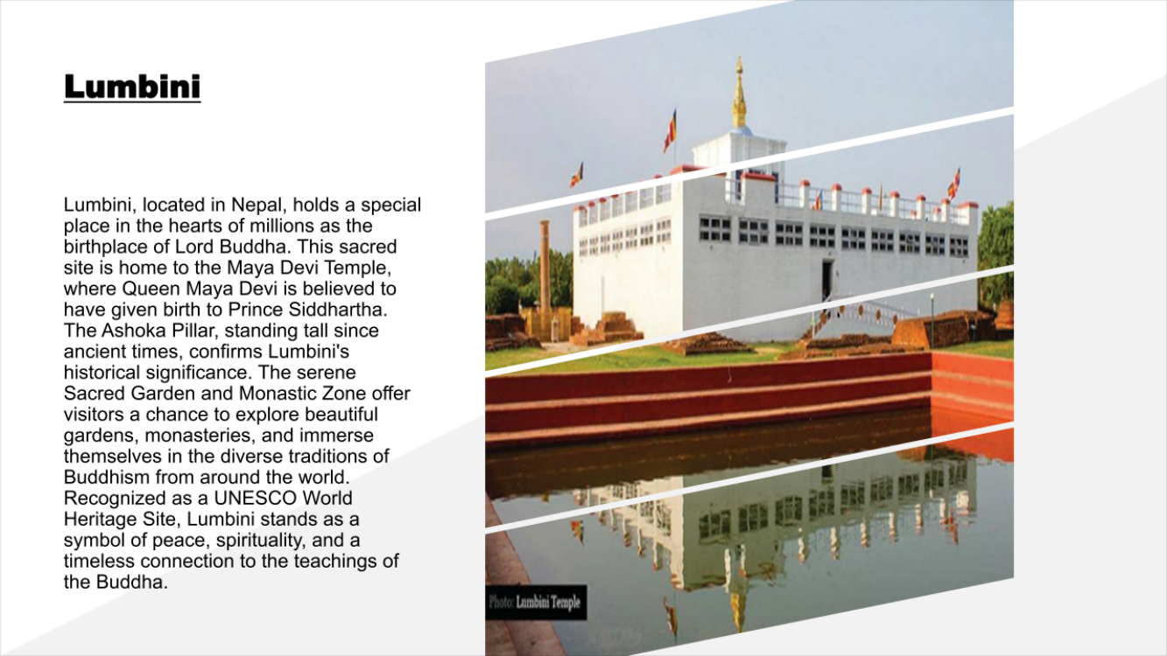

**RESULTS AND DISCUSSION :**

The experiment was successful to creating a presentation on nepal tourism using power point. The presentation contains pictures, texts with decoration, page decoration and so on.

**CONCLUSION :**

This laboratory exercise provided a hands-on experience in creating presentation using power point. Students gained practical knowledge of the basic in power point.